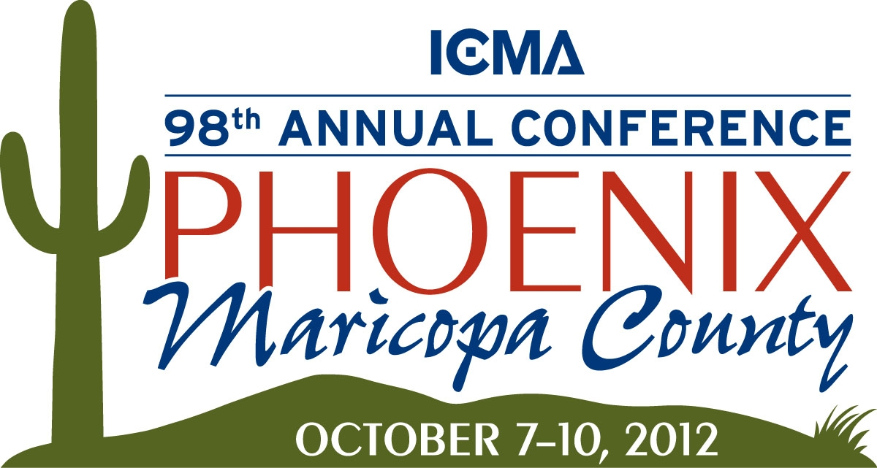

Volunteer Application

Thank you for your interest in volunteering at the 98th Annual ICMA Conference in Phoenix, Arizona. Assistance with various volunteer assignments and shifts are needed to make the conference a success.
Contact Information:

Name Email Address
Address Zip Code

Home Phone Cell Phone

Organization/Company

Dates available for volunteering (check all that apply):

___ Friday, October 5, 2012 ___ Monday, October 8, 2012

___ Saturday, October 6, 2012 ___ Tuesday, October 9, 2012

___ Sunday, October 7, 2012 ___ Wednesday, October 10, 2012

Preferred Volunteer Shift (check all that apply):

___ Morning (7a.m. – 11a.m.) ___ Evening (6p.m. – 9p.m.)

___ Mid-Day (11a.m. – 3p.m.) ___ Anytime

___ Afternoon (3p.m. – 6p.m.)

Shirt Size (Must include this information to receive a shirt)
___ Men’s ___ Women’s

___ Small ___ Medium ___ Large ___ XL ___ 2X ___ 3X

What is the level of your familiarity with the downtown Phoenix area?

___ Unfamiliar ___ Somewhat familiar ___ Very familiar

Please note any special needs, requests or any special areas of expertise you may have:

Email or Fax to:
Cynthia Aguilar - City of Phoenix - City Manager’s Office
volunteer@phoenix.gov
FAX 602-534-4492
Call 602-495-7195 with any questions.

